7.4: a) The rope makes an angle of 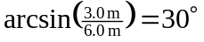 with the vertical. The needed horizontal force is then or 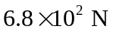to two figures. b) In moving the bag, the rope does no work, so the worker does an amount of work equal to the change in potential energy, Note that this is not the product of the result of part (a) and the horizontal displacement; the force needed to keep the bag in equilibrium varies as the angle is changed.

